ROCKY MOUNTAIN  
HIGH D’WAY

GUEST GUIDE

2024-2025

**Welcome to Rocky Mountain High D’Way!**

**We want to thank you for choosing our home away from home and hope you find it as peaceful and relaxing as we do.**

**We are a blended family with six children, 5 dogs and 2 cats. Ben retired in the spring of 2021 and I work full-time as a sales rep, so life is busy between visiting those that live away from home and spending regular time with those that are still in the area.**

**We are also blended in our interests – the beach is always my go-to spot and the mountains are my husband’s. But we all snow ski/board and love to hike around this beautiful county. Some of us climb and explore by ATV, others enjoy the local shopping and indulge in spa treatments.**

**Whatever your goals are while in Breckenridge, we hope you enjoy the scenery, are invigorated by the fresh mountain air and leave here a bit more peaceful than when you arrived. What a more spectacular place to unwind than quietly secluded in the Rocky Mountains…with all the amenities of Breckenridge nearby, it’s like city living without the constant distraction of the lights and noise!**

**Please enjoy yourselves and feel free to contact us at any time you are here with questions or if you need help with anything. If you like the beach, please visit *The Perfect Spot in Aruba(also listed on Airbnb)!***

**Enjoy your time, and please leave us a note – the best part for us is coming back and reading notes left from our guests!**

**Amanda and Ben Parrish**

**\*Press PLAY on the CD player for a hint of our inspiration!**

**Emergency Information**

***Home Address:***

**248 Coronet Drive, Blue River, CO 80424**

**Home Phone: (Behind fireplace cabinet) 970-771-3987**

***Red, White and Blue Fire Rescue:***

**120 Whispering Pines Road, Blue River, CO 80424**

**Phone: 970-771-3987**

***Breckenridge Police Department:***

**150 Valley Brook Street, Breckenridge, CO 80424**

**Dispatch Phone: 970-668-8600**

***Breckenridge Fire Department:***

**316 N Main Street, Breckenridge, CO 80424**

**Phone: 970-453-2474**

***Summit Medical Center:***

**340 Peak One Drive, Frisco, CO 80443**

**Phone: 970-668-3300**

**Home Information**

**WIFI: Comcast**

**SSID: HOME-Blue River**

**Password: 12345678**

**ROKU Log In:** [**queenofshefw@gmail.com**](mailto:queenofshefw@gmail.com)

**Password: Bracco123**

**You may sign into your favorite streaming services using your personal accounts – but don’t forget to sign out when you leave.**

**Laptop and Printer located on top floor for printing boarding passes, viewing restaurant menus, etc…extra paper and ink are in 2nd floor guest bathroom cabinets**

**Laptop PIN: 1111**

**Brinks alarm monitoring**

**For emergency repairs, contact *Amanda Parrish* at *(615) 828-4267* asap via text or call.**

**Feel free to enjoy a book from the shelfs downstairs, play a game, exercise on the elliptical or share a game of foosball.**

**There are sleds in the garage for you to enjoy if there is snow on the ground!**

**Restaurant Suggestions**

**\*our personal favorites**

***Grocery Order/Delivery***

**You may order groceries ahead of arrival to be delivered or picked up at the City Market**

**970-453-0818**

***Breakfast:***

**The Blue Moose**

**Columbine Café**

**Gold Pan Saloon**

**Daylight Donuts**

***Lunch/Dinner – Moderately Priced:***

**Breckenridge Brewery**

**Eric’s Downstairs**

**Columbine Café**

**Mi Casa**

**Flip Side Burger**

***Lunch/Dinner – Higher Priced:***

**Modi’s**

**Kenosha Steak House**

**Briar Rose Chophouse**

**Twist or Relish**

***Snacks:***

**Crepes a la carte (actually serves all meals) and Starbucks**

***Breweries:***

**Breckenridge Brewhouse**

**Broken Compass**

**Dillon Dam Brewery**

**Out and About in Breckenridge**

***Free Ride Parking Map and Routes* – see tab**

***Ski Lot Parking Map* – see tab or visit** [**www.Breckenridge.com**](http://www.Breckenridge.com)

***Outdoor Activities* – see tab or visit** [**www.gobreck.com**](http://www.gobreck.com)**, for information on dog sledding, snowmobiling, hot air ballooning, Nordic skiing, snowshoeing…**

***Ski Rental* – Ski Butler’s skibutlers.com**

**877-754-7754 will deliver to the house**

***Hair Salon:***

**Breckenridge Hair Company**

**Phone: 970-453-0800**

***Massage:***

**Breckenridge Mountain Massage**

**Phone: 970-453-7793**

***Grocery Stores:***

**City Market: 400 N Pkwy, Breckenridge, CO 80424**

**Safeway: 1008 Summit Blvd, Frisco, CO 80443**

**Walmart: 840 Summit Blvd, Frisco, CO 80443**

**Town of Breckenridge Parking Locations**

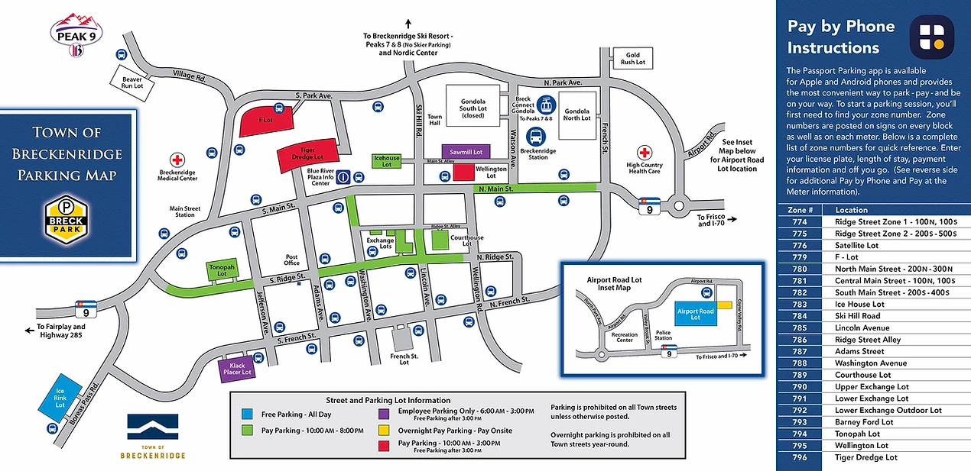

**Download the *Passport App* on your phone for a seamless parking experience and no waiting in lines to pay or get window ticket. The town is divided into zones so simply register your car, enter the zone and pay by phone!**

**Miscellaneous:**

* **Please do *NOT take glass into the hot tub* and bring in trash from deck after use**
* **Please do *NOT remove head cushions from hot tub* or other parts…should something break PLEASE notify me asap so I may contact the hot tub company**
* **Please *use caution when lifting the hot tub cover* and shut after each use**
* **Please be gentle with sliding screen door**
* **Please do *NOT FLUSH* anything down the toilet…only paper as it can cause future plumbing issues for next guests**
* **Please notice the disposal for the kitchen sink is on the *RIGHT not LEFT* and do not put food in the sink side.**

**CHECK OUT INTSTRUCTIONS:**

* **Leave ALL trash in bags in garage…this includes opened foods in fridge, freezer and on counter/shelves**
* **Run dishwasher before you leave and replace dishes to appropriate place**
* **Pull all sheets and towels and place on top of beds…please leave blankets and comforters/pillow shams in place**
* **Make sure *ALL remotes* are left in their respective rooms=-please do not move to different rooms.**
* **Make sure BOTH fireplaces are *turned OFF* and house lights turned OFF**
* **Lock the front door and RETURN the key (if used) to the lockbox**
* **Leave all extra KEYS in kitchen drawer**
* **Leave *GARAGE door REMOTES* in kitchen drawer**
* **Lock back patio door to deck**
* **PLEASE EMPTY THE REFRIGERATOR, FREEZER AND SHELVES OF ALL FOOD ETC…**

**Thank you for staying and have a safe trip home! Please come visit again. When you request to book, let me know you are prior renters so I can offer you a discount!**

**UPDATED COVID 19 PROCEDURES/PROTOCOLS**

**Any item listed here supercedes all of our normal rules and regulations found in the following guest guide.**

**If anyone is caught in violation of these orders, they will be asked to leave AirBnB and Summit County take Covid 19 very seriously, as we do as homeowners, and we appreciate your observance of these rules to keep other guests, local residents and the community safe.**

**Thanks in advance and have a great trip!**

**GUESTS:**

* **Guests are encouraged to take their shoes off when entering the property**
* **Guests should wash their hands frequently or use hand sanitizer**
* **Guests should wear cloth face coverings in public throughout CO.**
* **Guests should maintain physical distancing of at least 6’ from people not in their group/household while in CO.**
* **Guests must cancel their stay or leave if they are/become sick or in close contact with someone who has Covid 19 in the 14 days prior to their stay.**

**HOST:**

* **We have discontinued housekeeping services during your stay to prevent transmission between rooms**
* **We are providing extra towels, linens, pillow coverings and guest consumable items**
* **All hard surfaces and high-touch areas are completely disinfected with an EPA-registered chemical disinfectant between rentals**
* **We are providing hand sanitizer on each floor and personal kits when available**
* **We are allowing 24 hours between rentals to allow the home to be cleaned thoroughly and the air to clean out**